Fujitsu’s CORAL PA Spec.

Date : 2006/4/26

참고자료 : hm-mb86296s-rev1-00.pdf

- Overview
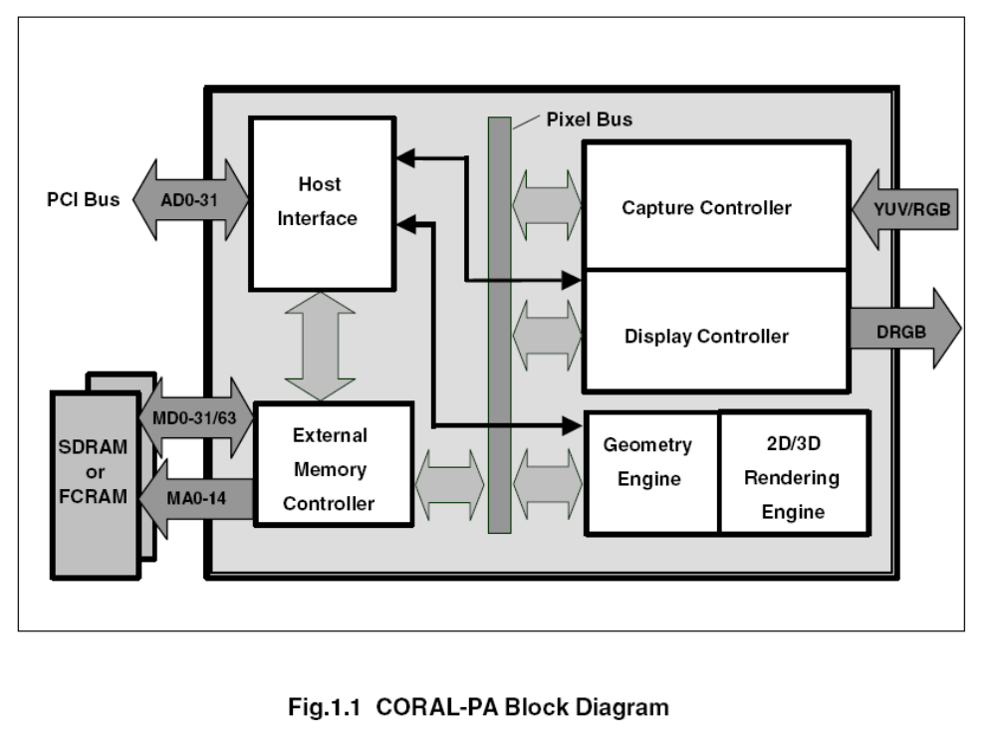
      - PCI ver 2.1 interface GDC
      - Geometry engine
      - 2D/3D graphic engine
      - Digital video capture
      - Display controller
      - External memory interface
      - EEPROM configuration
      - I2C interface for configuration
      - Include DMA
      - PLL
        - Operation freq. : 100/133/166MHz
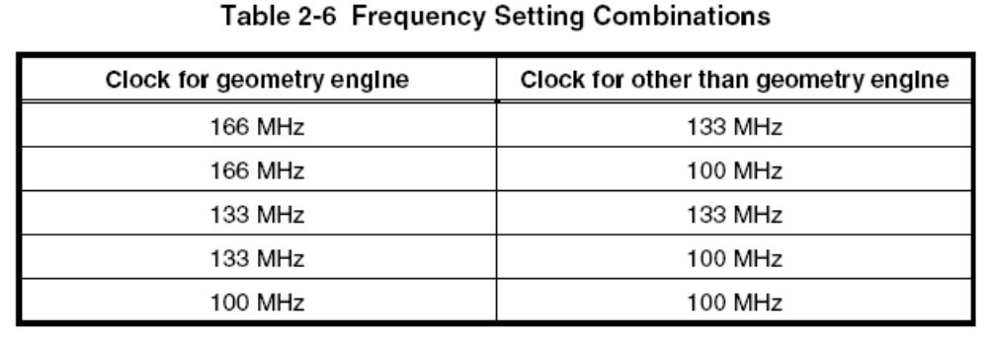
        - Display clock : max 400MHz
      - 0.18um

- Geometry Engine
      - ORCHID(MB86292) 호환
      - Primitives : Point, line, line strip, independent triangle, triangle strip, triangle fan, arbitrary polygon
      - MVP transformation : 4x4 transformation matrix
      - Clipping and Culling(not draw on the back)
      - 3D-2D transformation
      - View port transformation

- 2D drawing
      - CREMSON(MB86290A) 호환
      - Line
        - Bold line : 1~32 pixels
        - broken line : 32 or 24 bit pattern
        - Anti-aliasing smooth diagonal line
      - Triangle
        - Single color
        - 2D pattern
        - Texture mapping
          - Build-in pattern memory : 16bpp 64x64pixels
          - Texture pattern : max 4096x4096
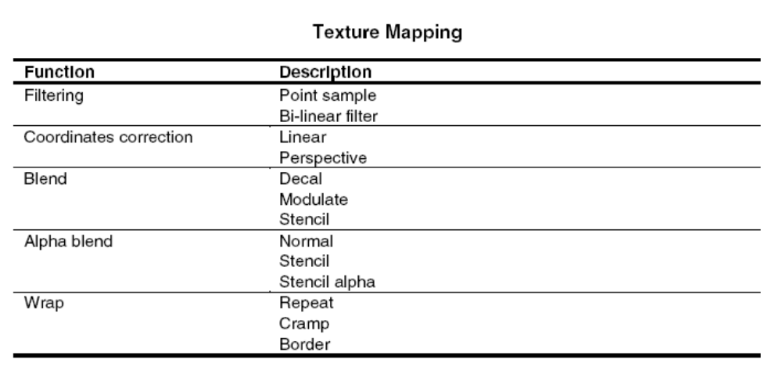

        - Alpha blending

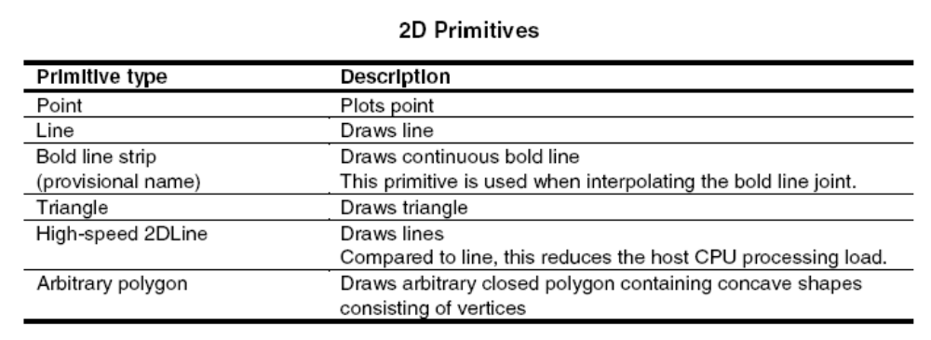
      - BLT/Rectangle drawing
      - Pattern(Text) drawing

- 3D drawing
      - No internal texture memory
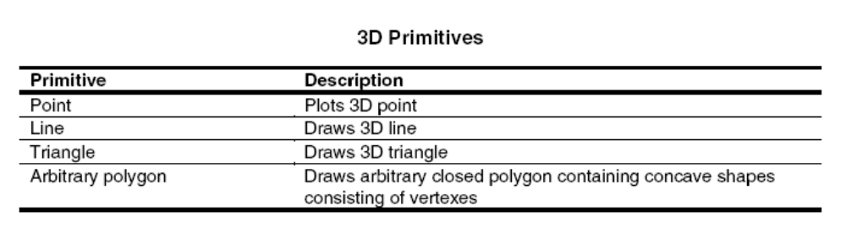
      - Texture mapping
      - Shading
      - Z buffer : Pixel의 깊이를 저장. 다른 pixel에 의해서 가려지는지 판단.

- Digital video capture
      - Store video data in video buffer
      - Input ITU-656, RGB666
      - Graphic memory에 저장 후, screen으로 display
      - Scaling : 1/32 ~ 2.
      - Image Processing
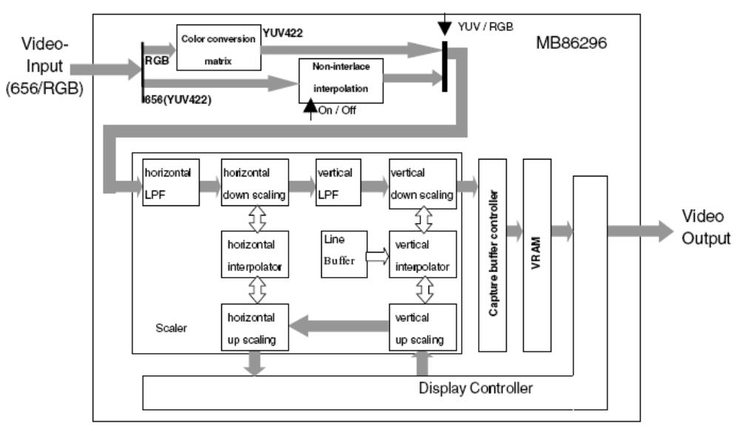

- Display controller
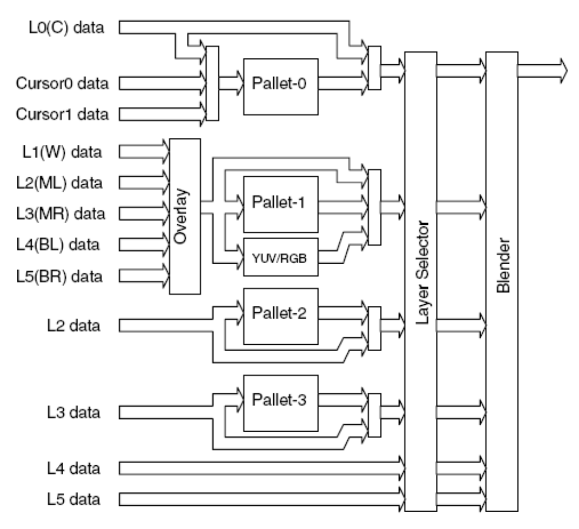
      - ORCHID 호환
      - Max size : 1024 x 768

      - 4-layer overlay(Compatibility mode)
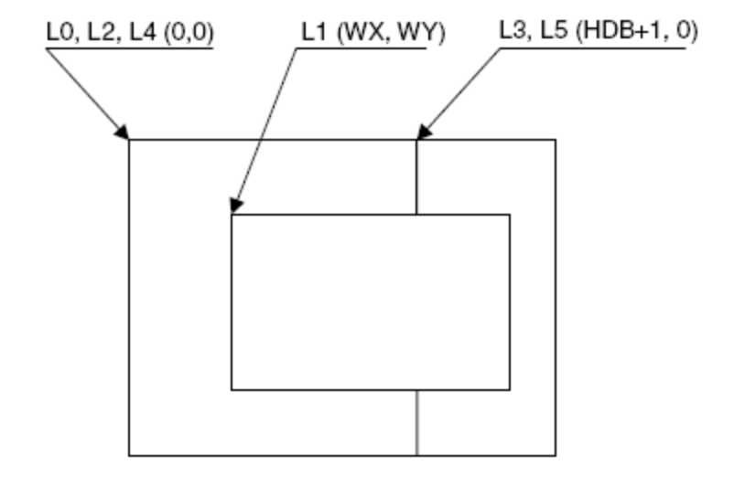
      - 6-layer overlay(Window mode)
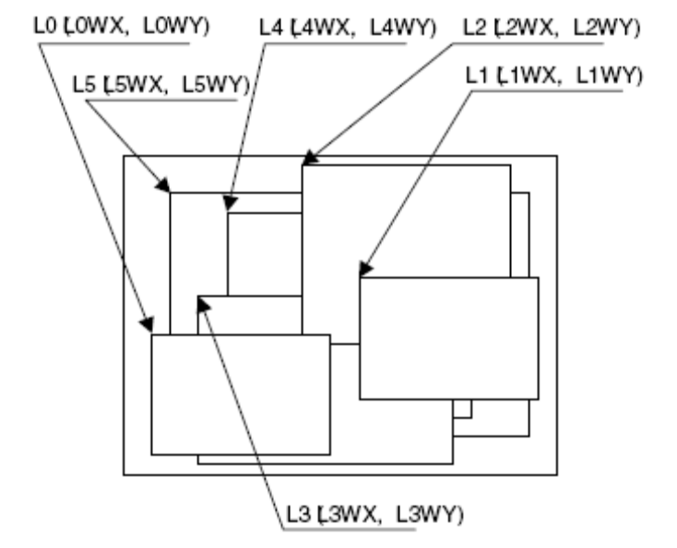
      - Left/right split display
      - Wrap around scrolling
      - Double buffers
      - Translucent display(alpha blending)
        - Blend ratio : 8bit for each layer
        - Blend flag : MSB of pixel data
      - 4 palette : convert 8 bpp color to 18bpp color
      - Direct color mode : 16bpp, 24bpp
      - Analog RGB video output
      - 2 hardware cursor : 64x64 pixel, 8bpp
      - Independent setting of drawing and display windows and their starting position

- External memory interface
      - SDRAM or FCRAM(fast cycle RAM)
      - Max 133MHz
      - Data bus width : 32 or 64
      - Graphic Data Type
        - Drawing Frame
16bpp color
8bpp color
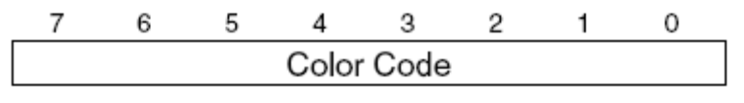
32bpp color
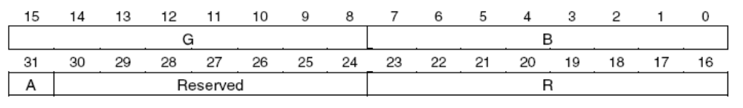
YCbCr=4:2:2
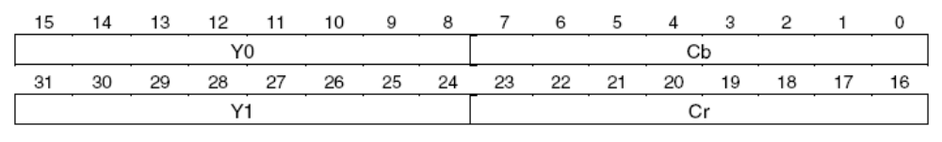
        - Display Frame
        - Z Buffer
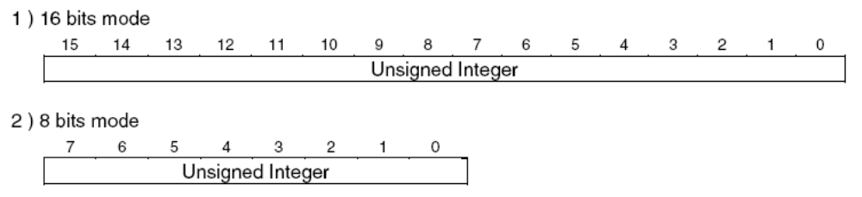
        - Polygon Drawing Flag Buffer
1 bpp
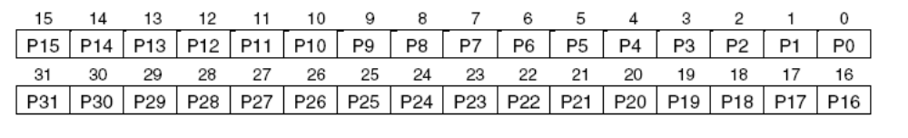
        - Display list Buffer : drawing commands and parameters
        - Texture Pattern
        - Cursor Pattern : 8bpp color, 64x64 pixels, 2 cursor

- Interrupt
      - Vertical sync. detection
      - Field sync. detection
      - External sync. Error detection
      - Register update
      - Drawing command error
      - Drawing command execution end
      - Burst/Transfer complete
      - GPIO input change
      - Internal Bus/FIFO Timeout
      - Serial interface transfer complete
      - Address Error(invalid address accessed)
- Color conversion
  - 5:5:5 → 8:8:8
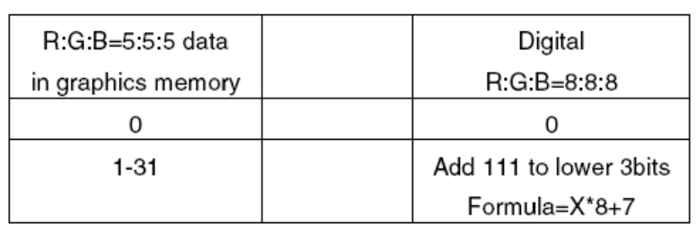
  - 6:6:6 → 8:8:8
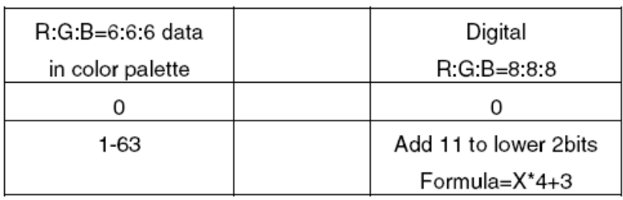
- Drawing Options
  - Bit Map Processing
    - Pattern data format
      - 1bpp color : character, font
      - 8bpp indirect color
      - 16bpp color
  - Texture Mapping
    - Texture size
      - 4 ~ 4096 pixels
    - Texture color
      - 8bpp direct color
      - 16bpp color

    - Texture Wrapping
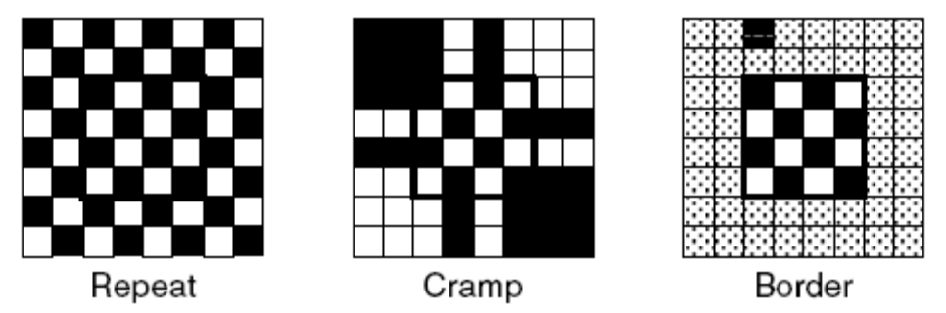

    - Filtering
      - Point filtering : nearest pixel is chosen
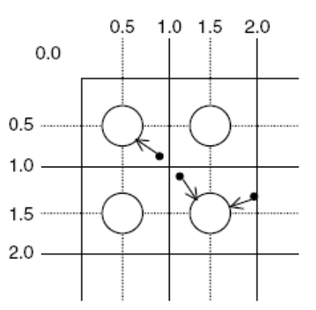
      - Bi-linear filtering : using distance
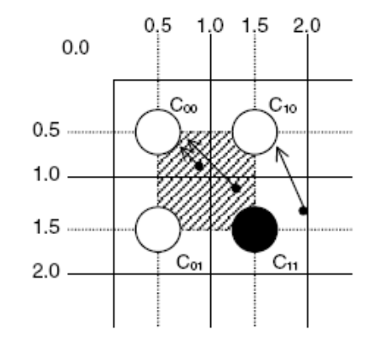
      - Perspective correction : Vertex 좌표(W)를 이용하여 원근감 보정
Q = 1/W
    - Texture blending : mapping color 결정
      - Decal : texture pixel color를 그대로 mapping
      - Modulate : texture color와 polygon color를 곱함.
      - Stencil : pixel의 MSB값(blending flag)에 따라 결정.
MSB=1 : Texture color
MSB=0 : Polygon color
    - Bi-linear high-speed mode
      - Bi-linear filtering mode
      - REPEAT wrapping mode
      - 16 bpp color mode
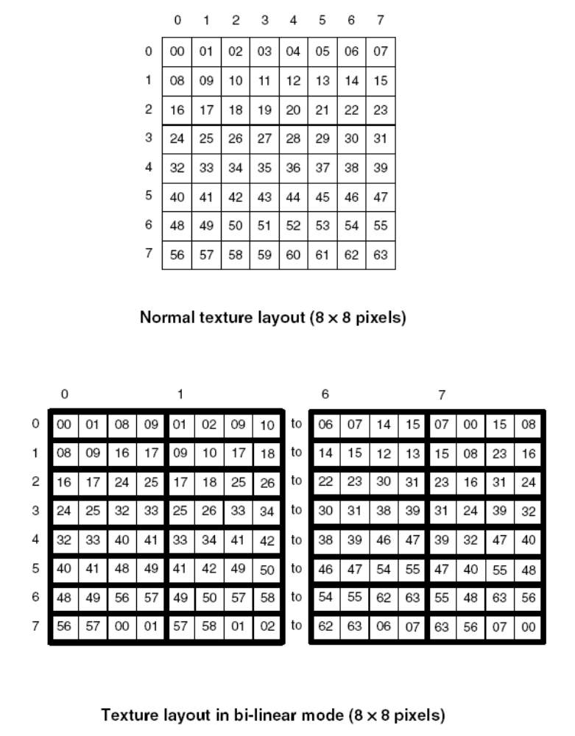
  - Rendering
    - Tiling
      - Read tiling pattern and mapping polygon
      - Pattern size : 64x64 pixels at 16bpp color
    - Alpha blending
      - Normal : using frame buffer color
      - Stencil : pixel의 MSB값(blending flag)에 따라 결정.
MSB=1 : Texel color
MSB=0 : Frame buffer color
      - Stencil alpha
MSB=1 : alpha blending
MSB=0 : Frame buffer color

    - Logic operation(Rater operation)
      - Alpha blending과 동시에 사용 불가.
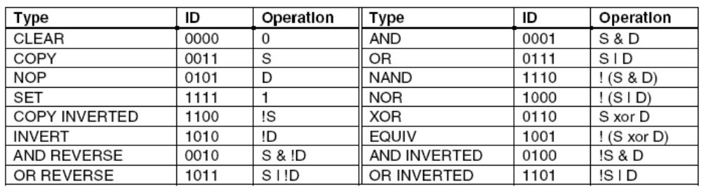
    - Hidden plane management
      - Z buffer
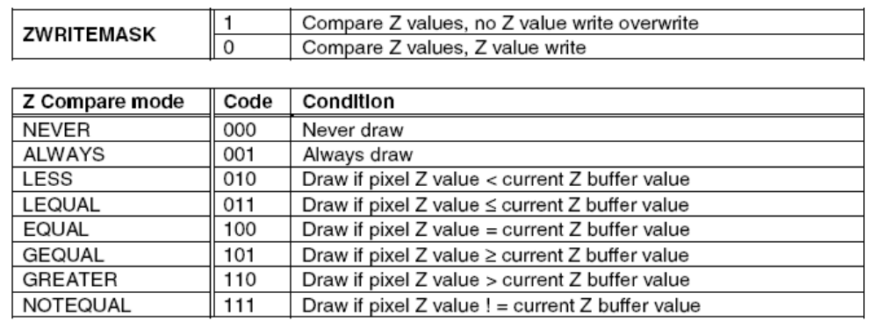
  - Drawing Attributes
    - Line drawing attributes
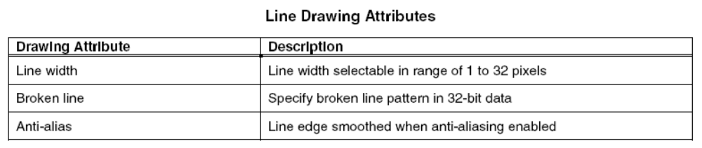
    - Triangle drawing attributes
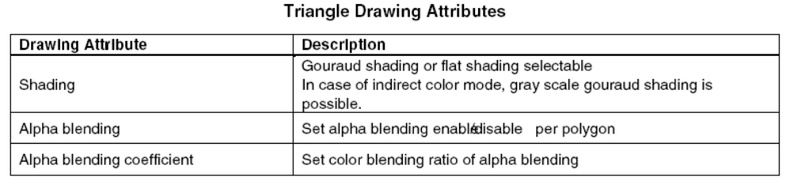

    - Texture attributes
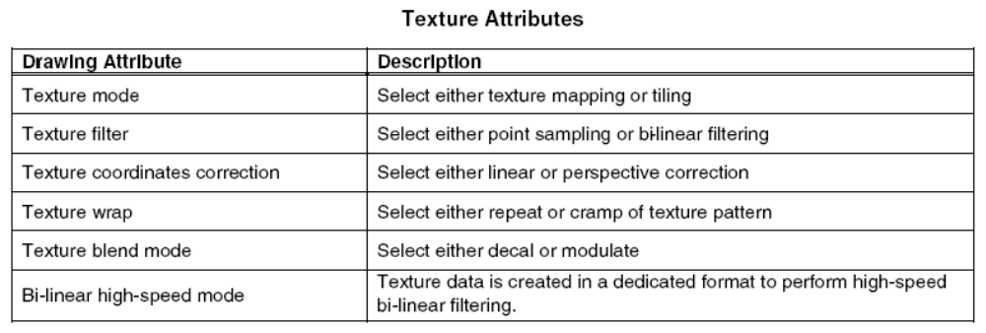
    - BLT attributes
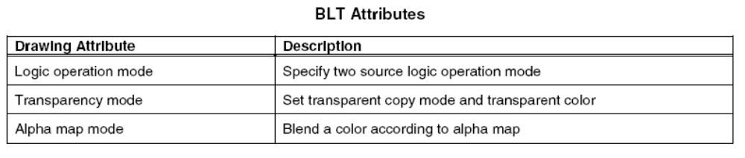
    - Character pattern drawing attributes
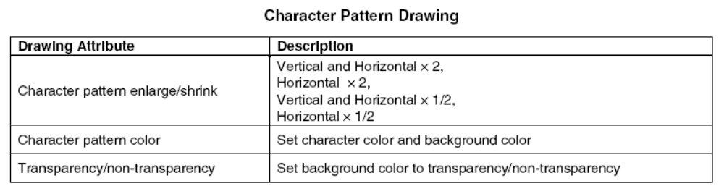
  - Bold Line
    - Starting and ending points
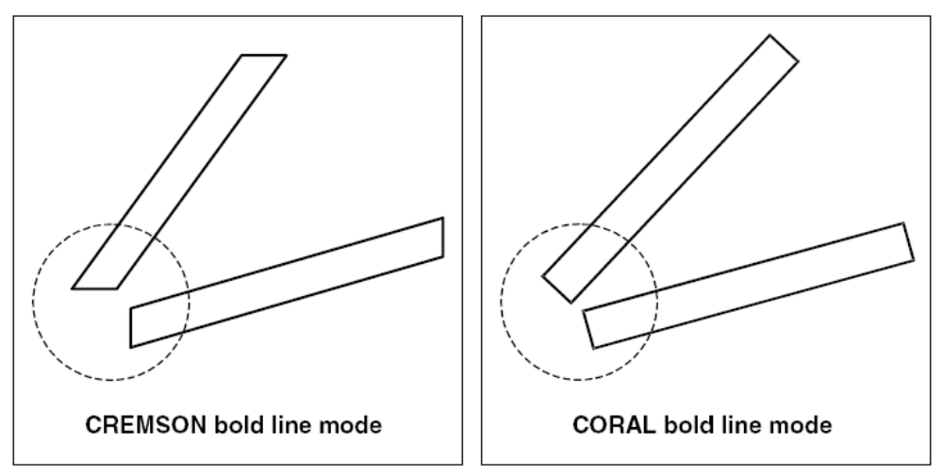

    - Broken line pattern
      - CREMSON bold line mode : CREMSON broken line pattern
      - CORAL bold line mode : only CORAL broken line pattern
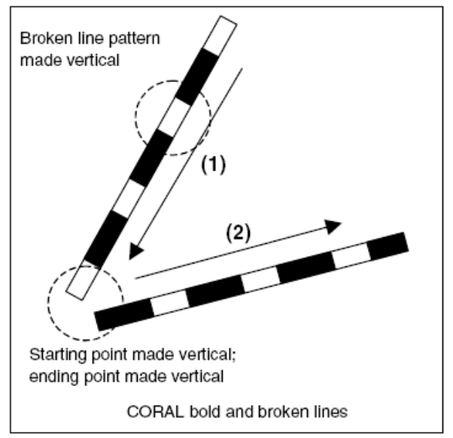
      - Interpolation of broken line pattern
        - No interpolation mode
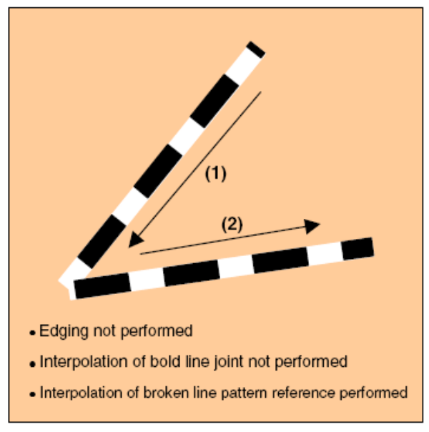

        - Broken line pattern reference address fixed mode
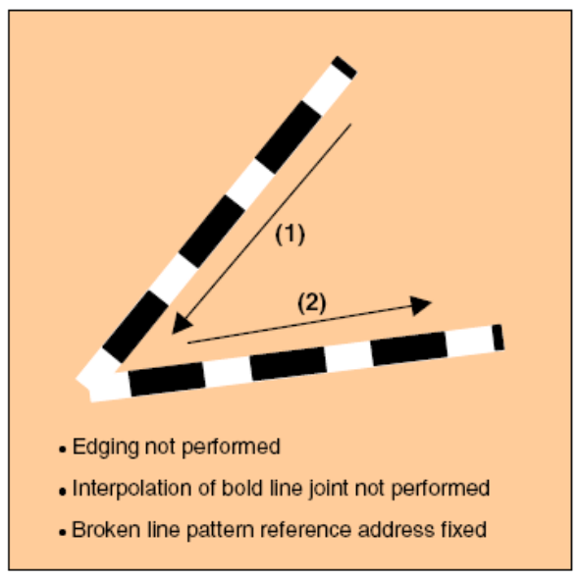
      - Edging
        - Support depth information(Z offset)
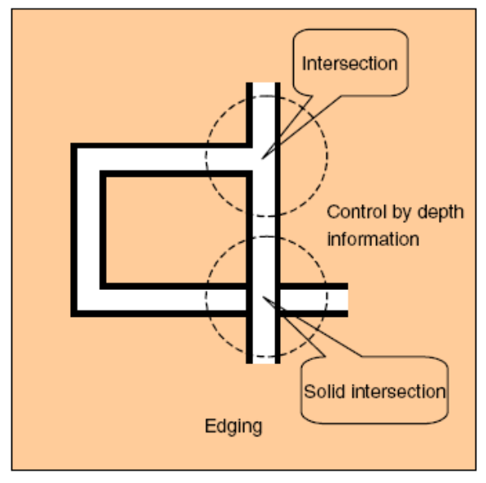

      - Interpolation of bold line joint
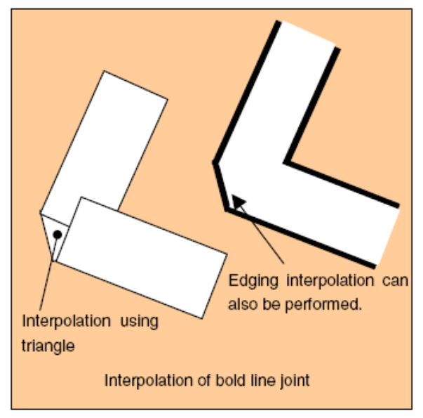
  - Shadowing
    - Using shift and z offset
    - Shadow composition line : avoid an overlay with body line
